***Asignment 1***

**1. What is software? What is software engineering?**

Ans : Software mostly refers to a set of instructions or programs or coding that tell a computer or another electronics device what to do and how to perform the task . It usually encompasses all the applications, programs, and operating systems that run on electronic devices like computers, smart phones, tablets, and other hardware. Software allows users to perform tasks, interact with digital content, and use devices effectively by translating user commands into actions that the hardware can execute. Examples include word processors, web browsers, games, and even the operating system itself, like Windows or macOS.

Software engineering is the process of building and maintaining computer programs in a structured way. It involves designing, writing, testing, and improving software to make sure it works well and does what users need it to do. It's like building a house: you plan how it should look, construct it with the right materials, check that everything works correctly, and make repairs or upgrades as needed over time. Software engineers typically work in teams, The goal of software engineering is to produce high-quality software that is reliable, maintainable, scalable, and meets user needs effectively.

**2. Explain types of software ?**

Ans : There are various types of software .

1. **System Software**: It manages computers hardware and provides a platform for running applications. Examples include operating systems (Windows, macOS, Linux).
2. **Programming Software**: This tools used by developers to create and maintain software applications. Examples include integrated development environments (IDEs) like Visual Studio, PyCharm, and IntelliJ IDEA.
3. **Application Software**: This type of software are Designed to perform specific tasks or functions for users. Examples include web browsers (Chrome, Firefox), word processors (Microsoft Word, Google Docs), and photo editing software (Adobe Photoshop).
4. **Middleware**: Software that acts as a bridge between different applications or systems. Examples include database management systems (MySQL, Oracle) and web servers (Apache, Nginx).
5. **Utility Software**: Especially design to provides tools to enhance system performance or perform maintenance tasks. Examples include antivirus software, file management utilities, and backup software.
6. **Business Software**: Mostly Supports business operations and management. Examples include enterprise resource planning (ERP) systems, customer relationship management (CRM) software, and accounting software.

These categories cover a wide range of software used in various domains and industries to fulfill different purposes and tasks.

**3. What is SDLC? Explain each phase of SDLC**

Ans : SDLC stand for Software Development Life Cycle. It is the process software developers use to create and manage software. It involves these Phases:

1. **Planning**: Figuring out what the software needs to do and who will use it.
2. **Analysis**: During this phase, the detailed requirements of the software are documented. This involves understanding user needs, defining functional and non-functional requirements
3. **Design**: The design phase focuses on how the software will be structured and how it will operate. This includes architectural design, database design, user interface design, and detailed module design. The goal is to create a blueprint that developers can follow to build the software..
4. **Building or Development** : Writing the code and putting together all the parts of the software.
5. **Testing**: Making sure the software works correctly and fixing any problems.
6. **Deployment**: Getting the software ready and putting it where people can use it.
7. **Maintenance**: Keeping the software up-to-date, fixing bugs, and adding new features as needed.

SDLC helps ensure software is well-made, works properly, and meets the needs of its users.

**4. What is DFD? Create a DFD diagram on Flipkart**

Ans : A Data Flow Diagram (DFD) is a visual representation of how data flows through a system. It illustrates the movement of data between processes, data stores, and external entities in a system. It uses defined symbols like rectangles, circles and arrows, plus short text labels, to show data inputs, outputs, storage points and the routes between each destination. Data flow diagrams were popularized in the late 1970s, arising from the book Structured Design, by computing pioneers Ed Yourdon and Larry Constantine. They based it on the “data flow graph” computation models by David Martin and Gerald Estrin.

Three common systems of symbols are named after their creators:

* Yourdon and Coad
* Yourdon and DeMarco
* Gane and Sarson

**An Illustration of DFD on Flipkart**

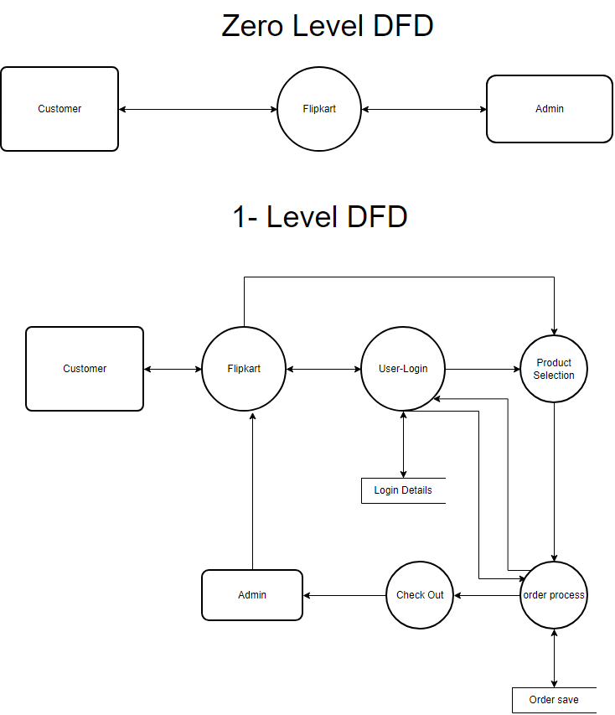

**5. What is Flow chart? Create a flowchart to make addition of two numbers**

Ans : A flowchart is a diagram that shows the steps or actions in a process. It uses symbols like circles, rectangles, and arrows to represent different stages or decisions in a sequence. Flowcharts help people understand how things work by visually breaking down complex processes into easy-to-follow steps. Flowcharts are widely used in various fields like software development, engineering, business processes, and more to analyze, design, document, and manage workflows effectively.

**Key Components of a Flowchart:**

1. **Start/End Point**: Indicates the beginning and end of the process with oval-shaped symbols labeled "Start" and "End".
2. **Process**: Represents an action or operation within the process with rectangular boxes. These boxes typically contain a verb or action statement (e.g., "Calculate total").
3. **Decision**: Represents a decision point or branch in the process flow where different decisions lead to different outcomes. It's usually depicted with a diamond-shaped symbol.
4. **Input/output**: Shows where data enters or leaves the process. Input is typically shown with a parallelogram, while output is shown similarly.
5. **Flow Arrows**: Arrows connect the symbols to show the sequence and direction of the process flow.

Benefits of flow are that it gives Clarity about software working and also helps Communications between team members and client. It helps to Analysis & training and troubleshooting.

**Flowchart of addition of two numbers**

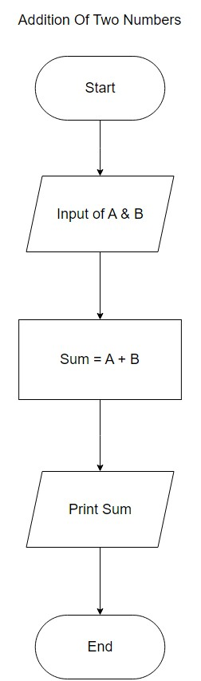

1. **What is Use case Diagram? Create a use-case on bill payment on paytm. ?**

Ans : A use case diagram is a visual representation in Unified Modeling Language (UML) that illustrates how users interact with a system. It shows the different ways users can interact with the system to achieve specific goals or tasks. Use case diagrams typically consist of actors (users or external systems), use cases (goals or tasks), and their relationships, depicted using actors, use case ellipses, and connecting lines. They help in understanding the functional requirements of a system from a user's perspective and are useful in the analysis and design phases of software development.

Main elements of a use case diagram include:

1. **Actors**: Represented by stick figures, actors are external entities (users or systems) interacting with the system
2. **Use Cases**: Represented by ovals, use cases describe the specific functionality or tasks the system performs to achieve a goal for an actor.
3. **Relationships**: Arrows connect actors to use cases to show which actors are involved in which use cases. Actors interact with the system by initiating use cases.

**Use-case on bill payment on paytm. (UML Diagram)**

